Module Seven Assignment: Additional Integration Using Jupyter Notebook

Part One: MongoDB Integration
This section documents a Python Jupyter Notebook that performs create, read, update, and delete (CRUD) operations against the delisweet MongoDB database, using the Nutrient Description (NutDes) record structure from previous modules. The notebook connects to a locally hosted MongoDB Community Server instance rather than the Codio cloud environment.

Integration Points
Several integration points connect the notebook to MongoDB. The connection itself uses the PyMongo MongoClient class to reach the server on localhost, port 27017. Connection parameters, including host, database, collection, and credentials, are read from an external database.conf file through a custom config() function built on Python's ConfigParser, keeping connection details out of the source code.
Security settings are a second integration point. Because this assignment was completed against a local MongoDB Community Server with authentication disabled by default, dbConnect() was modified to detect empty user and password values and, in that case, build a connection string without credentials (mongodb://host:port) instead of attempting to authenticate with blank values. This preserves the original authenticated behavior for any environment where credentials are required.
Query limitations are the third integration point. find() returns a cursor, so readRecord() converts it to a list before returning. update_many() and delete_many() were used instead of their single-document counterparts so the functions can affect every document matching a filter, which matters for a collection where a Nutrient Code could appear more than once.

Connecting to the Database and CRUD Functions
The dbConnect() function retrieves connection parameters from database.conf and returns a MongoClient connection, falling back to a credential-free URI when none are configured. Four functions then implement the CRUD operations against the NutDes collection: createRecord() uses insert_many() to add one or more documents and returns the inserted IDs; readRecord() uses find() and returns the matching documents as a list; updateRecord() uses update_many() with an update-operator clause such as $set and returns the count of modified documents; and deleteRecord() uses delete_many() and returns the count of documents removed.
def dbConnect(filename, section):
confData = config(filename, section)
if confData["user"] and confData["password"]:
conn = MongoClient('mongodb://%s:%s@%s:%d' % (confData["user"],
confData["password"], confData["host"], int(confData["port"])))
else:
conn = MongoClient('mongodb://%s:%d' % (confData["host"], int(confData["port"])))
return conn

# Create
result = collection.insert_many(data); return result.inserted_ids
# Read
return list(collection.find(clause))
# Update
result = collection.update_many(select, clause); return result.modified_count
# Delete
result = collection.delete_many(select); return result.deleted_count

Execution and Results
Each function was exercised against a Nutrient Description test record (Nutrient Code 777, Zinc) using a dedicated test function, and the notebook was executed top to bottom in Jupyter Notebook against the local delisweet database. The screenshot shows the configuration being read correctly, the existing document count, the successful insertion of the Zinc record, its retrieval by Nutrient Code, the update of its description from “Zinc” to “ZINC,” and its removal from the collection, with the affected-document count reported at each step.
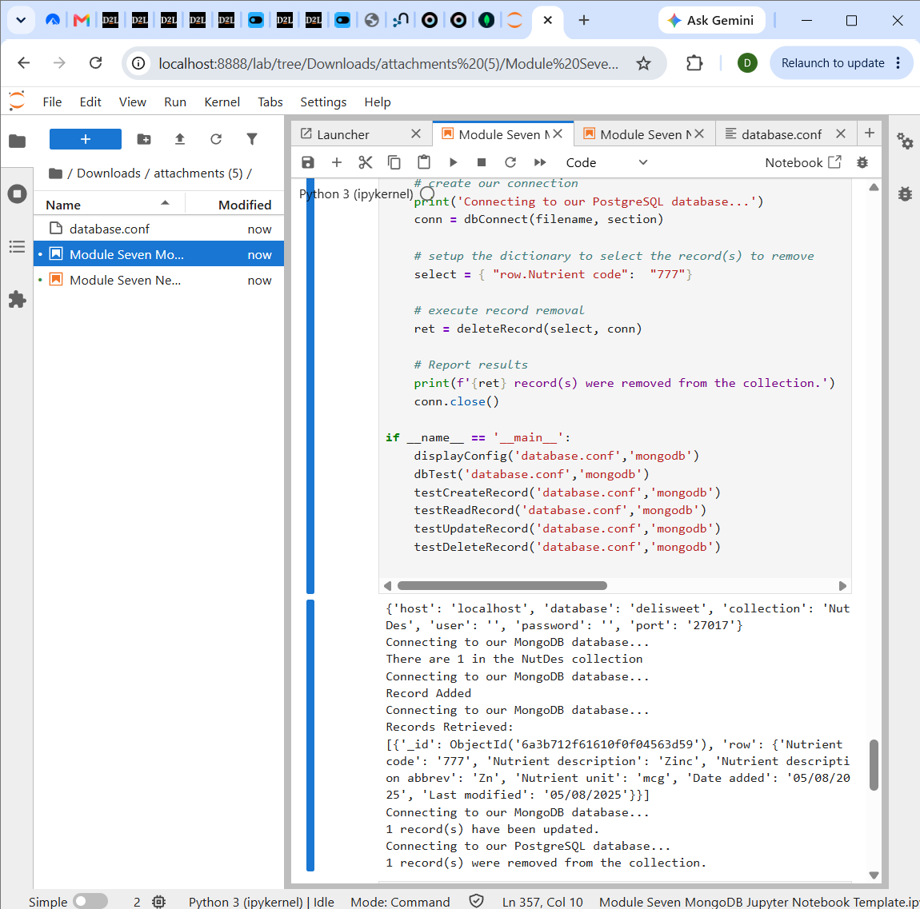
Successful execution of all four CRUD functions against the delisweet MongoDB database.

Part Two: Neo4j Integration
This section documents a Python Jupyter Notebook that performs CRUD operations against the maxiyum Neo4j graph database, using Neo4j Desktop running locally. The notebook follows the same Nutrient Description record used in Part One, represented here as a :NutDes node with flat properties rather than a nested document.

Integration Points
As with the MongoDB notebook, connection parameters, security settings, and query mechanics each represent a distinct integration point. Connection parameters are isolated in database.conf and retrieved through the shared config() function, specifying the Bolt protocol host, the maxiyum database name, and a username and password pair for the Neo4j DBMS.
Security settings differ from MongoDB because Neo4j Desktop requires authentication by default, with no no-auth fallback. dbConnect() therefore always supplies the configured username and password to GraphDatabase.driver() and calls verify_connectivity() immediately afterward, forcing an eager check of the credentials and the connection rather than waiting for the first query to fail.
Query limitations center on how Cypher statements are executed. Every CRUD function funnels through execute_query(), which executes a query against a single named database (passed with the database_ keyword argument) and returns a tuple of (records, summary, keys). A DELETE statement does not return rows, so deleteRecord() instead reports the node count from summary.counters.nodes_deleted rather than relying on the empty records list.

Connecting to the Database and CRUD Functions
The dbConnect() function builds a Bolt connection string that targets the maxiyum database directly and verifies connectivity before returning the driver object. createRecord() executes a MERGE statement, which creates the node if it does not already exist and matches it if it does, preventing duplicate Nutrient Code nodes across repeated runs. readRecord() executes a MATCH/RETURN statement and returns the resulting records, including the node's label and properties. updateRecord() executes a MATCH/SET/RETURN statement, applying a property update and returning the updated node. deleteRecord() executes a MATCH/DELETE statement and reports the node count from the query summary, since DELETE returns no rows.
def dbConnect(filename, section):
confData = config(filename, section)
URI = "neo4j://" + confData["host"] + "/" + confData["database"]
AUTH = (confData["user"], confData["password"])
conn = GraphDatabase.driver(URI, auth=AUTH)
conn.verify_connectivity()
return conn

# Create (MERGE avoids duplicate nodes)
records, summary, keys = conn.execute_query(cypher, database_=db); return records
# Read
records, summary, keys = conn.execute_query(query, database_=db); return records
# Update
records, summary, keys = conn.execute_query(query, database_=db); return records
# Delete (DELETE returns no rows, so report the summary counter instead)
records, summary, keys = conn.execute_query(query, database_=db)
return summary.counters.nodes_deleted

Execution and Results
The notebook was executed top to bottom against the maxiyum database running in Neo4j Desktop. The screenshot shows the connection being verified, the Zinc node (Nutrient Code 777) being created with MERGE, the same node being retrieved with its full set of properties, the node's description being updated from “Zinc” to “ZINC,” and the node being deleted, with the delete operation reporting one node removed.
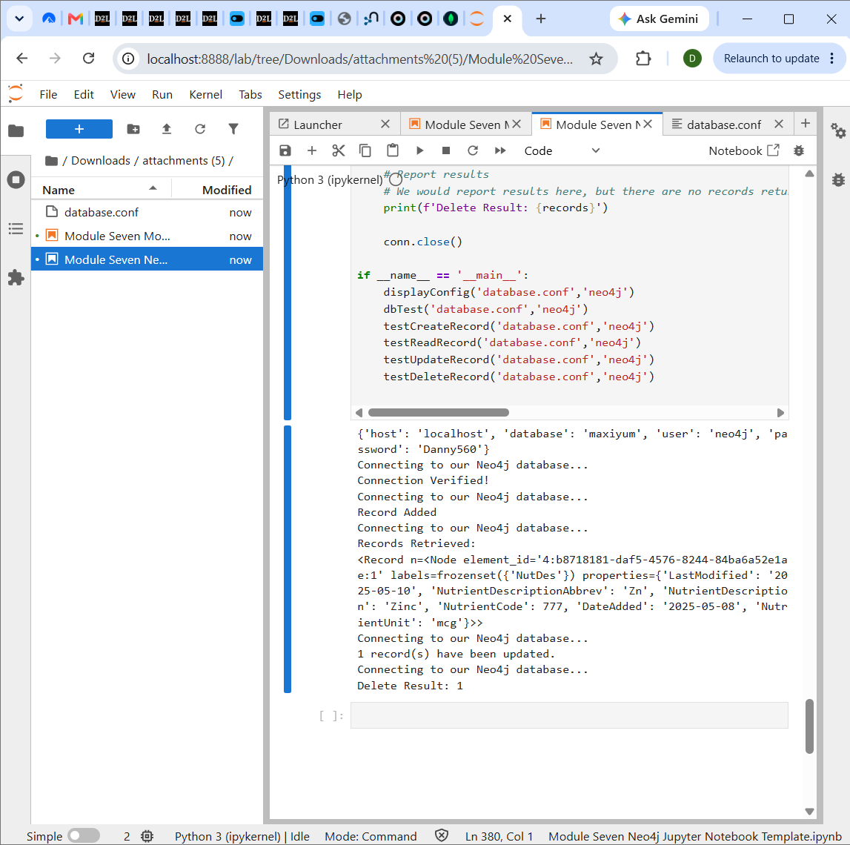
Successful execution of all four CRUD functions against the maxiyum Neo4j database.

Part Three: Reflection
Completing this assignment raised a practical question: under what circumstances would it make sense to use the Python code built here, rather than a database's own import tools, to extract, transform, and load (ETL) data into MongoDB or Neo4j?

Complexity of the ETL Process
The complexity of the transformation step is the biggest factor in this decision. A native tool such as mongoimport or neo4j-admin import is very efficient at moving data that is already shaped the way the target database expects, but it offers little room for conditional logic. The nutrient data used throughout this course illustrates why that matters: dates arrive in MM/DD/YYYY format and need conversion to ISO format, nutrient codes sometimes arrive as text when a numeric type is expected, and a few records contain blank or malformed values that need correction or exclusion. Writing the ETL logic in Python, using the same connection and CRUD functions built for this assignment, makes it possible to validate, reshape, and clean each record before it is written, which is the right approach once the transformation step involves more than a straight column-to-field mapping.

Impact of the Data Source
The source of the data directly affects this decision. A clean, well-documented export from a single internal system is a reasonable candidate for a native bulk-import tool, since the structure is already known and unlikely to vary. The value of a custom Python pipeline rises quickly once data must be combined from multiple sources of different shapes and quality. If the nutrient data were instead pulled from several supplier feeds, a government database, and a manually maintained spreadsheet, a Python ETL script could read each source individually, apply source-specific transformation rules, and reconcile differences in field naming before writing into a single collection or node label, something a native import tool is not designed to do.

Validation in a Python ETL Process
A Python-based ETL process also creates an opportunity to validate data before it is committed, which is harder to add to a native import tool after the fact. Useful validation for this dataset would include confirming each Nutrient Code is present and numeric before insertion, checking that a Nutrient Description is not empty or duplicated under a different code, verifying date fields can be parsed and converted before they are written, and wrapping each write in a try/except block, similar to the dbConnect() functions built in this assignment, so a single bad record raises a clear error rather than corrupting the dataset.

Performance Considerations
Performance is where the tradeoff becomes clearest. Native bulk-loading tools are almost always faster for large volumes of already-clean data, since they are written in lower-level code, can disable indexing during the load, and avoid the overhead of a Python interpreter and a network round trip per batch. The custom Python CRUD functions written for this assignment are better suited to smaller volumes, frequent incremental updates, or situations where records need to be inspected or transformed individually. In practice, a reasonable strategy for this dataset would use Python to clean and validate the data once, then hand the cleaned result to a native bulk-import tool for the high-volume load, combining the strengths of both approaches.

